
K&M Tire

Information Technology – Programming
05/20/2022

TABLE OF CONTENTS
Information Technology – Programming i
1. K&M Tire 1
2. Office Manual Introduction 4
3. Organizational Chart, Contacts and References 5
3.1 Organizational Chart 5
3.2 3CX – Phone System 5
3.3 Location Contact List 5
3.4 Organizational Information / Links 5
3.5 Programming SOP - Reference Documentation 5
4. On Call Rotation and Responsibilities 6
4.1 Support Flow 6
4.2 Determining Severity 6
4.3 Rotating Assignments 6
4.4 Additional Developer ‘on call’ Protocols 7
5. SSL/TSL Certificate Renewal 8
5.1 Renewing Certificates 8
6. Creating PHP/Jquery Programs 10
6.1 Purpose 10
6.2 PHP Standards 10
6.3 Functions 10
6.4 Control Statements 11
6.5 Strings 11
6.6 SQL Standards 11
6.7 Jquery Standards 13
6.8 Error Trapping Documentation 14
6.9 Analytics 15
6.10 Locations 15
7. Creating RPG Programs 17
7.1 Purpose 17
7.2 RPG Standards 17
7.3 SQL Standards 18
7.4 Error Trapping Documentation 19
7.5 Analytics 21
7.6 Locations 22
8. Remote Work Tracking 24
8.1 Purpose 24
8.2 Workspace 24
8.3 Time Tracker 25
8.4 Dashboard 25
8.5 Reports 26
8.6 Projects 27
8.7 Support 27
9. Departmental KPIs for Development 28
9.1 Total Tickets Solved 28
9.2 Average Time to Resolution 28
9.3 Total Time Open 28
9.4 Projects Closed for the Month 28
9.5 Estimated vs Actual Completion Time 28
9.6 Online Order Statistics 28
Frequently Asked Questions 29

K&M Tire


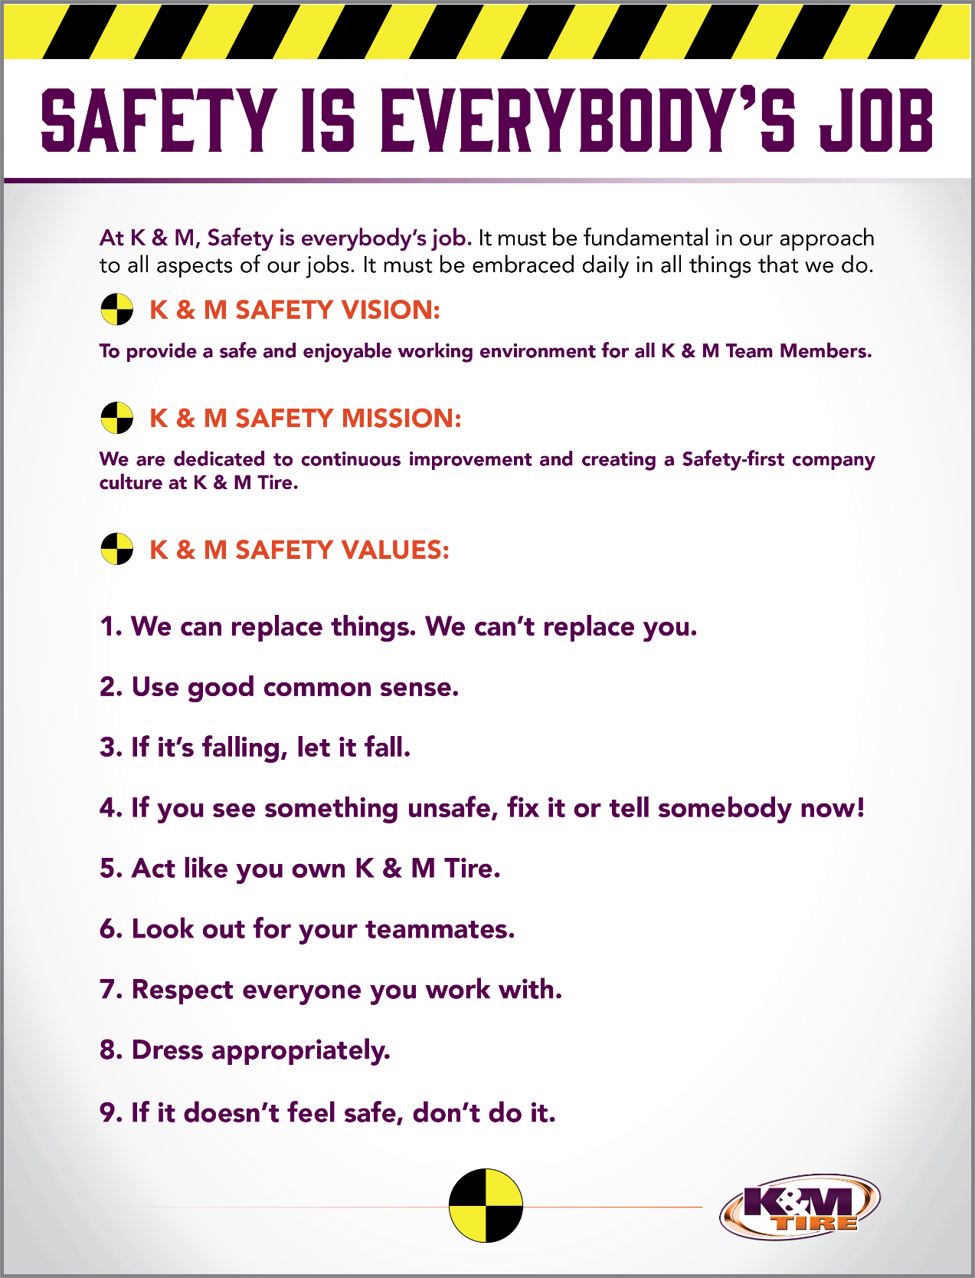

K&M Tire US Footprint
Click on the below link to see the footprint map
http://kmtire.com/km-cgi/distmap

Office Manual Introduction
This manual is intended to aide in the training of the K&M Tire Information Technology team by providing step by step detail of the processes.

Click this link to find the most up-to-date version: F:\SOP\IT\Approved

Information Technology processes and procedures found within this SOP may contain sensitive information about K&M Tire. This SOP is to remain secured, private and limited to internal K&M Tire associates. It is also not to be saved or shared outside of the K&M Tire network.

Organizational Chart, Contacts and References

Organizational Chart
https://login.paylocity.com/Escher/Escher_WebUI/views/employeeportal/employeePortalOrgChart.aspx?area=home&view=coOrgChart

3CX – Phone System
F:\SOP\Administrative Assistant\Pending Approval\3CX - Phone Instructions.pptx

Location Contact List
F:\Administrative Assistants\Public\Location Cheat Sheet.xlsx

Organizational Information / Links
Paylocity/Self-Service Portal/Teams

Programming SOP - Reference Documentation
F:\Information Technology\Shared\OneNote\Procedures\Programming.one
Please visit the above link for additional programming documentation on any of the below topics:
-Amazon -Adjustments -AMI -Cleo
-Dashboards -Dealer to Dealer Sites -EDI -Intranet
-MaddenCo -New Location Setup -Nightly Jobs -Support
-Table Details -Training & Documentation -Weblink -Web Service
-WISE -Zend Server Portal -Signature Capture -SSL Certs
-Errors & Outages -Time Change -Walmart Processes -FTP Request
-Razor SQL Setup -SQL Errors -New User Setup -API Keys
-Mobile Deposit/Chase -Muse KMTIRE.com -Scheduled Jobs -GitHub
-API Access – Internal -Create Order Process -Zip Codes -Test API
-Console Setup -Marketing Program Maint. -AP Dashboard -Jira
-Paylocity Demo Site -MSGW Notes

On Call Rotation and Responsibilities

Support Flow
- IT Support takes phone call
  - If it is a programming issue it will be forwarded via call or email to all programmers;
  - Programmer on call will attempt to resolve issue;
  - If the programmer on call cannot solve the issue, they will ask other available programmers;
  - If all programmers are unable to solve, they would then escalate it to the Development Manager;
  - If the Development Manager is unable to solve the problem, he would contact any free / already paid support service to for help in solving issue;
  - If the issue is still present and additional paid services are required, the Development Manager, Director of IT, IT Business Analysis, and/or VP of Information Technology would meet and decide best course of action.

- IT Director, Upper Management, VP of IT calls directly
  - Unless it’s a major outage the same flow would be applied.
  - If it’s a major outage, the issue should be sent directly to the Development Manager and escalate as appropriately documented in section 9 of the IT Support SOP document which is labeled “Call Escalation”.

Determining Severity
- Critical Incident
  - A customer-facing service, like Weblink, is down for all customers
  - Confidentiality or privacy is breached
  - Customer data loss

- Major Incident
  - A customer-facing service is unavailable for a subset of customers
    - Example: Location 84 customers can’t get onto Weblink
  - Core functionality (create KM Orders, Intranet Down)

- Minor Incident
  - A minor inconvenience to customers, workaround available
    - Example: Label won’t print for Amazon
  - Usable performance degradation

Rotating Assignments
- Responsible party
  - Every week one designated programmer will be the point of contact for all on call issues
  - If that person is unavailable during the week the Development Manager will step into the role or assign it to another programmer
  - If the Development Manager or on-call are unable to determine/fix problem then Development Manager will:
    - Call to outside support group for covered outages
  - In the rare event that no one on the programming team can be reached, OneNote has documentation and call #’s for IBM I and Zend Server under the following titles:
    - Restarting Zend, Apache
    - Zend Server Support Portal
    - IBM, I issues/Contact can be found in the Secure One Note
  - Development team understands that nights and weekends are sometimes part of the job expectations

Additional Developer ‘on call’ Protocols
- “On call” is a necessary function of our IT department due to the importance of our systems being functional at all hours of company operations. If K&M were to experience an outage of any specific system this affects our ability to serve our customers. In turn, we would lose the trust of our customers which goes against our company vision.
- Clearly define the on-call responsibilities
  - Follow clearly defined rotation schedule provided by Development Manager to avoid burnout, confusion, and frustration.

- Make sure alerts are being assigned to the right person
  - IT support is responsible for routing programming calls.

- Have primary and secondary responders
  - Defined into 4.3 Responsible Party

- Fine-tune your schedules
  - Make sure that all cover outages have a person responsible that can solve the issues in an efficient and timely manner

- Development Manager to ensure the team has access and is familiar with all the relevant diagnostic tools
  - Ensure access to knowledge base in ticketing system, OneNote and SOP documents

SSL/TSL Certificate Renewal

Renewing Certificates

- Renewing our certificate validates our website's identity. It makes sure the encryption is up to date, which keeps the user's data secure during transit. If this were to expire it creates an extra step for customers to access a website causing confusion.
- K&M Tire Inc has two websites which need periodic certificate renewals.
  - Tireimages.com is hosted through Network Solutions, https://www.networksolutions.com/.
    - We are automatically charged via corporate credit card saved on their web portal.
  - The kmtire.com cert is purchased through Godaddy, https://www.godaddy.com/.
    - We are automatically charged via corporate credit card saved on their web portal.
- IT uses a wildcard cert, a single cert for multiple systems, and generate one valid copy for three servers.
- It is the responsibility of the Network Administrator to verify the steps are completed in a timely manner to eliminate disruption to our customers.
- Individual steps for the Dev Team Member are documented in OneNote under Procedures > Programming > Renew 3rd Party SSL Cert
Notes:
The instructions for Godaddy and Exchange are located at: https://www.godaddy.com/help/exchange-server-2016-install-a-certificate-27338
- In order to create a cert, a server has to generate a corresponding CSR.
  - A CSR is a Certificate Signing Authority which is one of the first steps towards getting your own SSL/TLS certificate.
  - The CSR contains information (e.g. common name, organization, country) the Certificate Authority (CA) will use to create your certificate.
- The CSR has a key.
  - When a Dev Team Member installs the cert onto the server which made the CSR, it completes it making a valid cert.
- A Dev Team Member then exports the completed cert into a readable public/private pair that other servers can pick apart.
- On the Exchange server, the System Administrator will import the cert into Windows and then tell Exchange to assign it to services.
- On the 3CX server, the System Administrator further breaks the file down into different formats that the phone system requires.
- Certs are monitored using the system admin calendar with notifications of dates for certification renewals as shown below:
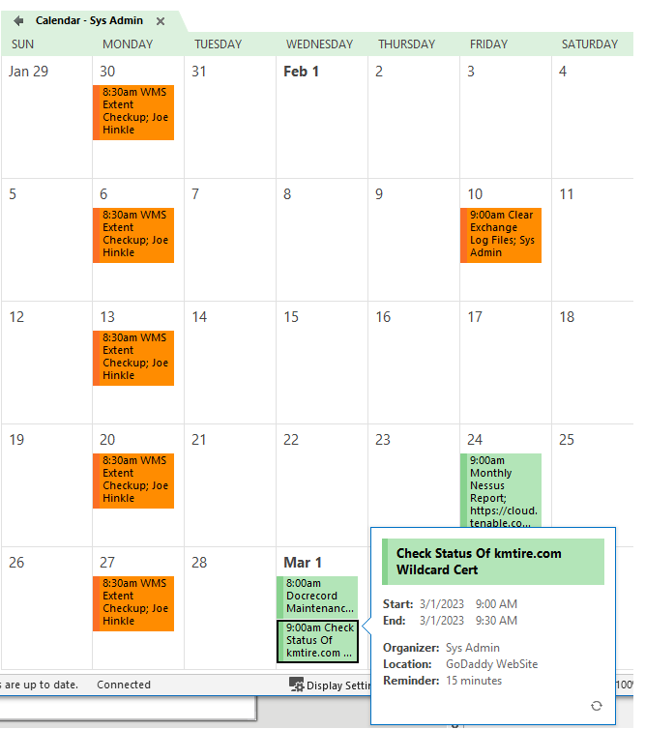

Creating PHP/Jquery Programs

Purpose
- To give the standards of PHP and creating a program. PHP is a replacement for RPG as our server-side programming, it is a free language within itself and is affordable as part of the Zend Server Package.
- A good benefit of using PHP is that it can interact with many different database languages including DB2.
- PHP also has very good online documentation with a good framework of functions in place. This makes the language relatively easy to learn and very well supported online. There are countless forums and tutorials on various PHP methods and problems so it is usually very easy to find help if you need it.
- Due to PHP being so accessible and cheap to setup there are a lot of people who know how to use the language which makes finding new employees proficient in this language less challenging.

PHP Standards
- Variable Standards
  - All PHP Variables start with a ‘$’. Variable names should be camelCase and use of underscores is discouraged. Variable names should be descriptive. Use of single character variable names such as $i is allowed for loops only.
    - $customerNumber = 1234567;
    - $orderQty = $_POST[‘qty’];
    - $custPrice = $_POST[‘price’];
    - $extPrice = $quantity * $price;

Functions
- Function names should be camelCase. Function names should be descriptive and use minimal abbreviations. Functions will usually start with a verb (view, get, etc.). Functions should include a comment block above them giving a brief description of the function. The opening and closing braces should appear on their own lines and should align with the start of the function declaration. Code within the function should be indented two spaces to the right.
  - Example
$orderQty = 5;
$custPrice = 25.00;
getExtendedPrice($orderQty,$custPrice);
/*
* Calculate extended price based on ordered quantity and
* customer’s price
*/
function getExtendedPrice($orderQty, $custPrice)
{
Return $orderQty * $custPrice;
}

Control Statements
- Control statements should have a single space between the control statement and the opening parentheses of the conditional statement. Within the parentheses, operators should be separated by spaces to improve readability. The opening and closing braces for control statements should appear on their own lines and should align with the start of the control statement. Code within the control statement should be indented two spaces to the right.
if ($orderQty > $availableQty)
{
$backorderQty = $availableQty - $orderQty;
}
else
{
$backorderQty = 0;
}
while ($row = db2_fetch_both($stmt))
{
echo “Row Fetched.”;
}

Strings
- There are two preferred methods for concatenation, using ‘.’ between two strings or including {$varName} within a string. When using {$varName} within a string, the string must be wrapped in double quotes, not single quotes. When using ‘.’ there should be a space before and after the ‘.’. In most cases strings should be wrapped in double quotes.
echo “Quantity Ordered: ” . $orderQty;
echo “Customer Price: {$custPrice}”;

SQL Standards
- SQL Statements
- The db2_prepare function should be used to create prepared statements from a variable containing the SQL statement. Any parameters in the query will be bound using db2_bind_param, not concatenated. SQL Statements should be in all caps and aligned according to the examples below.
- Binding Parameters is a security issue and will be critically important to front end sites

Select Query
$query = “SELECT B.DESC, SUM(A.QTY) AS QTY, B.PRICE
FROM TESTZEND.TESTORDL A
JOIN TESTZEND.TESTPROD B
ON A.PRODID = B.ID
WHERE A.ORDHID = ?
GROUP BY B.DESC, B.PRICE”;
$stmt = db2_prepare($conn, $query);
db2_bind_param($stmt, 1, ‘orderNum’, DB2_PARAM_IN);
db2_execute($stmt);
while ($orderDetails = db2_fetch_array($stmt))
{
echo trim($orderDetails[0]) . “ “ .
$orderDetails[1] . “ “ .
$orderDetails[2];
}

Insert Query
$insert = “INSERT INTO TESTZEND.TESTORDH
(ID, CUSTID, DATE)
VALUES
(?, ?, ?)”;
$stmt = db2_prepare($conn, $insert);
db2_bind_param($stmt, 1, ‘orderNum’, DB2_PARAM_IN);
db2_bind_param($stmt, 2, ‘custNum’, DB2_PARAM_IN);
db2_bind_param($stmt, 3, ‘orderDate’, DB2_PARAM_IN);
db2_execute($stmt);

Update Query
$update = “UPDATE TESTZEND.TESTORDL
SET QTY = ?
WHERE ID = ?”;
$stmt = db2_prepare($conn, $update);
db2_bind_param($stmt, 1, ‘orderQty’, DB2_PARAM_IN);
db2_bind_param($stmt, 2, ‘lineId’, DB2_PARAM_IN);
db2_esecute($stmt);

Multiple SQL Binds
- You can establish an array and bind to SQL this way very efficiently
$colors = array (‘gold’,’blue’, ‘silver’, ‘green’);
for($i = 0; $i < count($colors); $i++)
{
$filter = $colors[$i];
$$filter = $filter;
db2_bind_param($stmt, ($i+1), $filter, DB2_PARAM_IN);
}

Jquery Standards
- Jquery is a lightweight “write less, do more”, Javascript library. It is used to have seamless data transactions through object orientated programming

Variable Standard
- Var stringName = “string Name”;
- Var numberValue = 50;
- Var startArray = [];

Functions
- If a button has a class of resetPassword
$(document).on("click", ".resetPassword" , function(e) {
e.preventDefault(); //prevent default action
var conf = confirm('Are you sure you want to move forward'');
if (conf == true)
{
//Run Ajax into reset password function in ajax file
}
});

Ajax
$.ajax({
type: "POST",
url: “Point to URL “url-ajax.php”
data: { action: "direct to function", passVariables: passVariables},
success: function(data)
{
//Notify user things went successfully
Alert(‘Processed’);
}
});

Control Statements
if (hour < 18) {
greeting = "Good day";
} else {
greeting = "Good evening";
}

Error Trapping Documentation

Overview
- There is one part to error trapping in PHP/Zend
- http://10.73.0.10:10100/ZendServer/
  - Login
    - Monitoring -> Logs
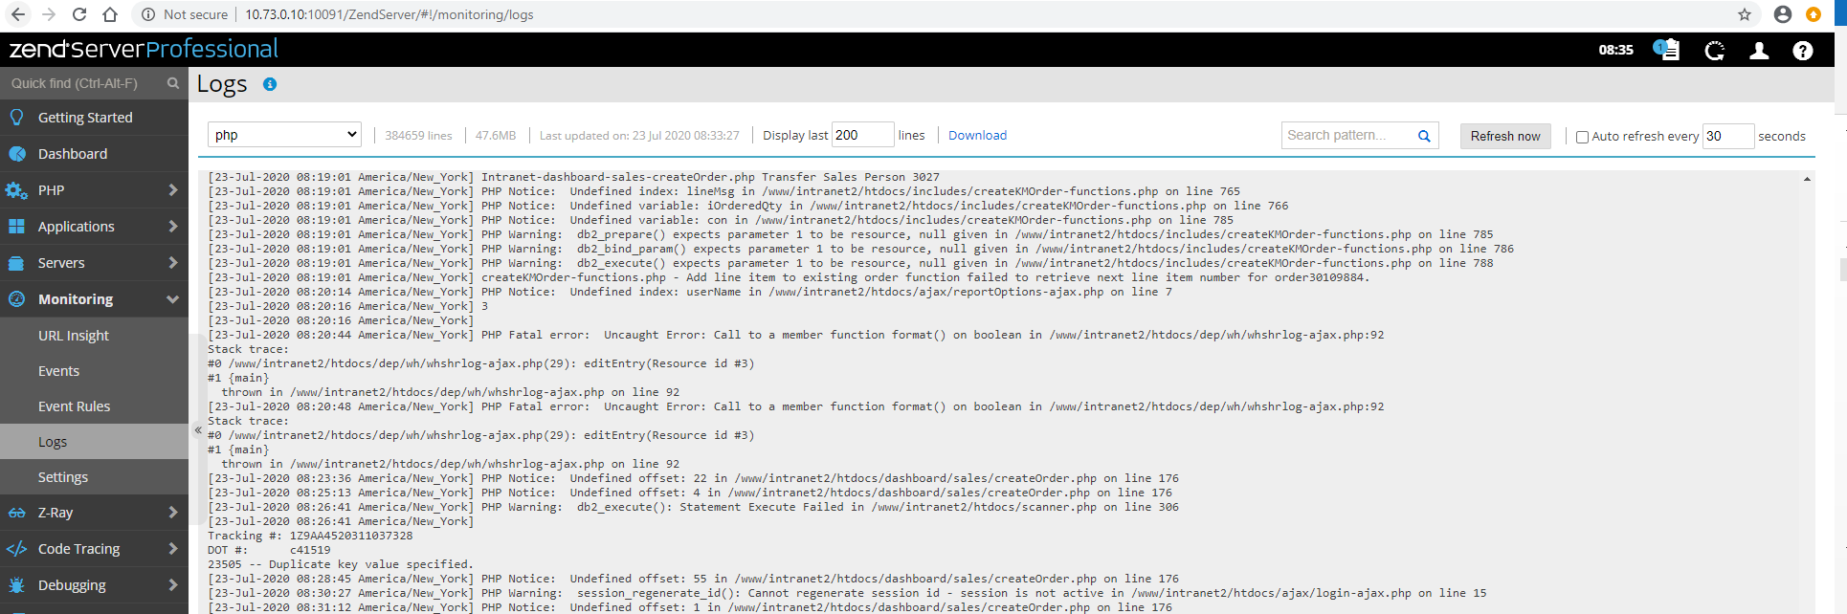

Error logging type
- Error
  - These are fatal run-time errors that halt script execution, such as running out of memory or calling a function that does not exist.
- Warning
  - A run-time warning is an error that does not halt script execution but can cause your code to not work as expected. For example, fopen() will return false and trigger an E_WARNING if you try to open a file that does not exist. The rest of your code won’t be able to read or write to the requested file.
- Parse
  - These are compile-time parse errors, like missing parentheses or semicolons.
- Notice
  - Notices indicate possible bugs, such as using a variable that doesn’t exist in an expression. This could mean the variable name has a typo or needs to be assigned some value earlier.
- Strict
  - These errors indicate places in your code that may stop working in future versions of PHP. Using mysql_query() will trigger a strict error because the extension that provides that function is deprecated, and in fact is not bundled in PHP 7.

Analytics
- Analytics are used to gather data about customer facing website usage. The data is gathered using a call to a function and is stored in file INTRANET2.ANALTYICS or KMTDTA.ANALYTICS
- There is one part to analytics in PHP and it’s built it the Intranet.

Function for Analytics
- Php made it very easy to keep track of things
- A one line call to a function will keep a record of every Ajax or Form Submission.
insertAnalytics("whpaynote-ajax.php", $conn);

Locations

File, Library, Information, and HTTP address
\\10.73.0.10\www\ Folder Details
Folder | Information | Host Site
Dev\Intranet | Development side for Intranet 2. Includes Dashboards under dev\Intranet\dashboard | http://10.73.0.10:93/Intranet/index.php
Intranet | ERPG files for Old Intranet (Html) We change DEPID for to access to different departments site list | http://10.73.0.10:91/e-rpg/depindex?DEPID=6
Intranet 2 | Live side of Intranet | http://intranet.kmtire.local
Mrtest | Testing Module Development website | Obsolete Not Used
Mrtire | Mr. Tire handled by marketing | http://mrtireoutlet.com
Mrtiretl |  | Obsolete Not Used
Signatures | Physical copies of Signatures from signature capture | N/A
Tireweblink | Dealer to Dealer Website ERPG files(Front End to RPG) | http://jamtire.tireweblink.com/
Weblink |  | Obsolete Not Used
Weblink 2 | Weblink 2 Website ERPG files (Front End to RPG) | https://weblink2.kmtire.com/
Webservices | Front facing API, ACH Processing, Signature Capture | https://webservices.kmtire.com
Zendphp74 | Jobs setup to run nightly | http://10.73.0.10:10100
Zendsvr6 | Old Zend Directory | Obsolete Not used

Creating RPG Programs

Purpose
- RPG programs are still hosting Weblink 2, Tire Web Link, API connections, and a host of other nightly files. IT Development is continuing to migrate programs over but it’s important for all programmers to have an understanding of RPG programming for proper conversions, and troubleshooting of existing programs.

RPG Standards
- D-Spec/Variable Standards
  - Every variable should have a space after D-spec and start with a lower-case purpose indicator.
    - S – SQL Variable
    - W – Work Variable
    - I – Input/Form Variable
  - Variables should be camel case after the indicator and should have a trailing type indicator to let you know the data type of the variable. A # symbol indicates a numeric field. A @ symbol is used for character, date, time, and timestamp fields.
    - sCustNum#
    - wTimeStamp@
    - iUserName@
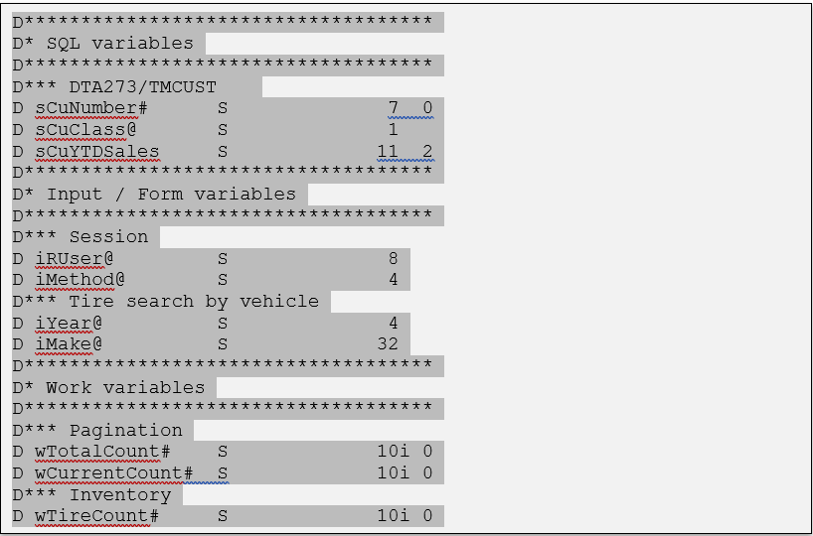
- Free Naming and Programming Standards
  - Subroutine names should start with a dollar sign and should typed in camel case.
    - $GetUserInformation
    - $SaveUserInformation
    - $CalculateOnHand
  - All logical blocks, including subroutines should be indented 2 spaces after they have begun and should have a leading and trailing blank line, as well as a blank line after the opening tag. All RPG functions should be in camel case.
    - DoW
    - If
    - Else
    - EndIf
    - EndDo
  - All Built In Functions should be lower case.
    - %char()
    - %trim()
    - %scan()
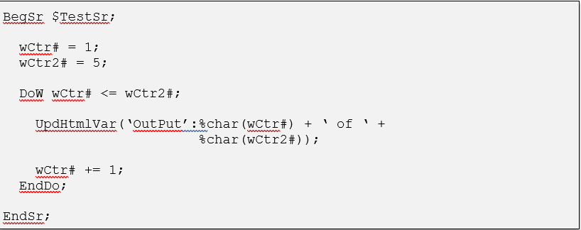
All line breaks should be aligned with the above line where the adjoining output or logic is.

SQL Standards
- SQL Statement
  - SQL Statements should be in all uppercase except for RPG variables used in WHERE and FETCH statements.
  - SQL statements are aligned to the last letter of the SQL keyword. This forms a row of blank spaces between the SQL keywords and the field and file names. (See source below)
  - Always wrap SQL SELECT statements in a cursor even when you only expect one row to be returned. Cursor names should be meaningful to help with troubleshooting programs. Always remember to close your cursors.
  - Always wrap aggregate functions and fields from files linked by LEFT OUTER joins in IFNULL.
- Error Trapping
  - To trap SQL errors and prevent endless loops, when looping through and SQL CURSOR always test SQLCOD as:
    - DoW SQLCOD = 0 Or (SQLCOD <> 100 and SQLCOD >= 0);
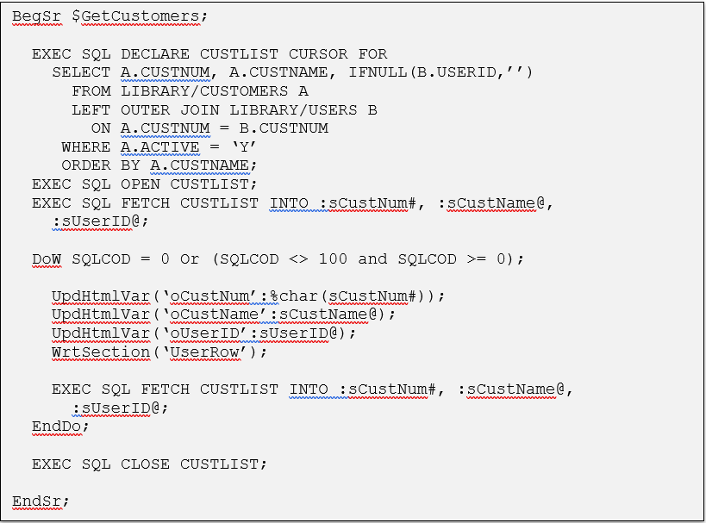

Error Trapping Documentation
- Overview
  - There are two parts to the Error Trapping:
    - Program Errors
    - SQL Errors
  - Program errors are trapped using the Monitor Op Code. SQL errors are trapped by checking the SQLCOD variable.
  - When an error occurs the $Error subroutine is called. The $Error subroutine is stored in the copy book SYSSUBSSRC. This subroutine displays a message to the user letting them know that an error occurred and ends the program. The subroutine also sends an email to notify IT of the error. The variable that the email is set in is ERROREMAIL. This email is set by default to webdeveloper@kmtire.com. The ERROREMAIL variable can be set to the programmer’s email address for testing purposes.
  - Example Programs:
    - INTRANET/SAANARPT
    - INTRANET/SAOSCOM
    - INTRANET/HROSCOM
- Program Errors
  - Error trapping for program errors is performed using the Monitor op code. The Monitor op code is inserted prior to the program specific code. At the end of the program specific code the On-Error op code is entered. Code to be executed is entered below the On-Error op code. EndMon finished the block of error code.
  - The ERRORMSG variable is set in the On-Error; block. This variable is copied into each program via copy book, so you do not have to enter it yourself. The message is set to display the program error message and the line number that the error occurred on. These variables are from the program status data structure and are entered into every program via copy book.
  - See below for an example of the Monitor and On-Error code blocks:
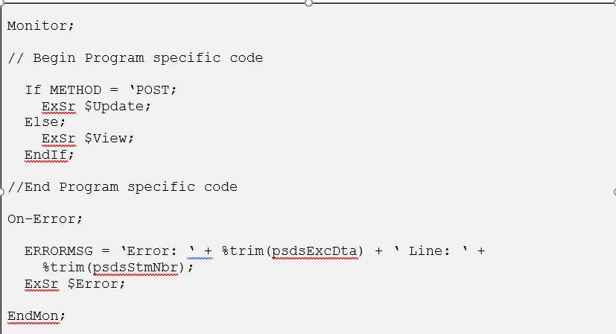
- SQL Errors
  - Errors are trapped by checking the SQLCOD variable. The SQLCOD variable is set automatically each time an EXEC SQL statement is run. The value of this variable determines if a read was successful (0), if we reached the end of the file (100), or if an error has occurred. Any SQLCOD value less than 0 means that an error has occurred.
  - When executing a DoW loop for a dynamic SQL statement or an SQL statement with a variable in the where clause, SQLCOD should be checked for a value less than 0 after the EndDo but before closing the cursor. The code for the DoW loop should also test for SQLCOD of less than 0. This will prevent endless loops from occurring when there is an SQL error.
  - If the SQLCOD variable is less than 0 then the ERRORMSG variable should be set and the $Error subroutine should be called.
  - See the next code as an example:
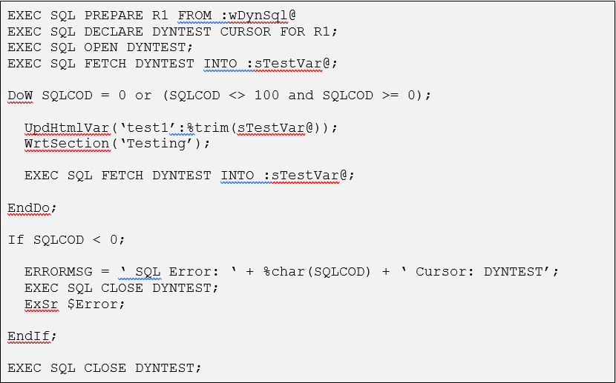

Analytics
Analytics are used to gather data about customer facing website usage. The data is gathered using a call to a Sub-Procedure and is stored in file KMTDTA/ANALTYICS. The Intranet has its own analytics procedure that is copied in automatically, and is not included in this section.
There are three parts to Analytics, a binding directory, a copy book, and a sub-procedure call.
- Binding Directory
  - The binding directory, KMTSYS, needs to be added to the H specs with keyword BNDDIR. Most programs should already have the BNDDIR H spec entry.
    - H DFTACTGRP(*NO) BNDDIR(‘KMTCGI’:’KMTSYS’:’QC2LE’:’QUSAPIBD’)
- Copy Book
  - The copy book is KMTSYS and is located in the source file QCPYSRC in KMTPGM. It is copied into the D specs.
    - D/COPY KMTPGM/QCPYSRC,KMTSYS
- Sub-Procedure Call
  - The sub-procedure is ANALYTICS. It can be called in the *INZSR or at the start of the program. It accepts two parameters, domain ID and program name. The program name is usually accessible using variable name psdsPgmNam. It is part of the PSDS and is copied into most programs. In Fixed Format programs you may need to specify the program name yourself. The Sub-Procedure gathers data about how the user is accessing the program and writes it to a file.

Locations
- File, Library, Information and HTTP address
File | Library | Information | Host Site
QRPGLESRC | KMTIRE | Programs on public facing KM Tire website | http://Internal.kmtire.Local/  (kmtire.com)
QRPGLESRC | WEBLINK2 | Programs on Weblink 2 Live Side | https://weblink2.kmtire.com/
QRPGLESRC | WEBTEST2 | Backup and development area for weblink 2. | http://webtest2.kmtire.local/  (Note: If this isn’t running  - System I Navigator  - 10.73.0.10  - Network  - Servers  - TCP/IP  - Right click HTTP Administration  - Start Instance Webtest 2
QRPGLESRC | KMTPGM | No front facing side. Create Order Process, FTP file sends, and API Code (Inventory, Vendors, Size Search, and Orders) | http://kmtire.com/test/  (Multiple Tests for API Responses)
QRPGLESRC | INTRANET | Old Intranet File wrote in RPG. Some Reports are still active and linked in Intranet 2 | http://10.73.0.10:91/e-rpg/depindex?DEPID=6
QRPGLESRC | TIREWEBLNK | Dealer To Dealer Website | http://jamtire.tireweblink.com/  Username: D1C0U1  Password: test
QRPGLESRC | KMTLIB | Custom Programs In Madden Co Menus
QCLSRC | KMTPGM | Command Line – Backups, Scheduled Jobs (RPG), qryf and wrkactweb
QCLSRC | KMTLIB | Ranking Report (Old)
QMODSRC | KMTPGM | Get KM Price (Old Intranet Only)
QDDSSRC | KMTDTA | All Database files for Intranet, Intranet 2
QDDSSRC | KMTDTAS | Secure Files with confidential information
QDDSSRC | WEBTEST2 | All Database files for Webtest 2
QDDSSRC | WEBLINK2 | All Database files for Weblink 2
USRPRF | TIREWEBLNK | All Tire Weblink files are setup like this not just USRPRF -> See Razor for full listing if needed
QDDSSRC | INTRANET | Only Sessions for Old Intranet
QDDSSRC | INTRANET2 | All database files for Intranet 2 and HR Analysis
QDDSSRC | DEVXXX | Test Library for each programmer Example DEVACH
QDDSSRC | EDIDTA | All Database files for EDI Projects
BALANCESHE | DOWNLOAD | Exports from Madden Co files are setup like this not just BALANCESHE -> See Razor for full listing if needed
QTEMP |  | In the event that we would need to recover File or Library we would store it here temporarily

Remote Work Tracking

Purpose
- To accurately show how we use Jira’s app Clockwork (Free Currently) to capture time against projects. This helps us to estimate project time and track against hours against not just projects (Epics) but, broken down task underneath.
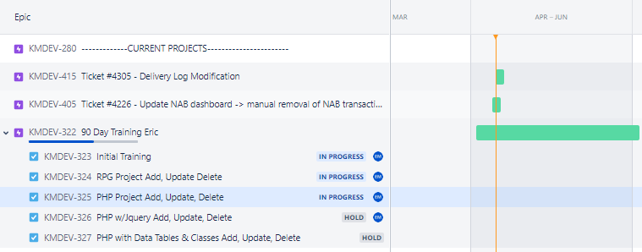
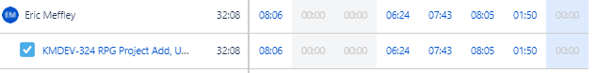

Workspace
- Administrator sends invite to email through admin.atlassign.com
  - Can setup into Specific Roles or Groups.
- User gets email and can setup password.
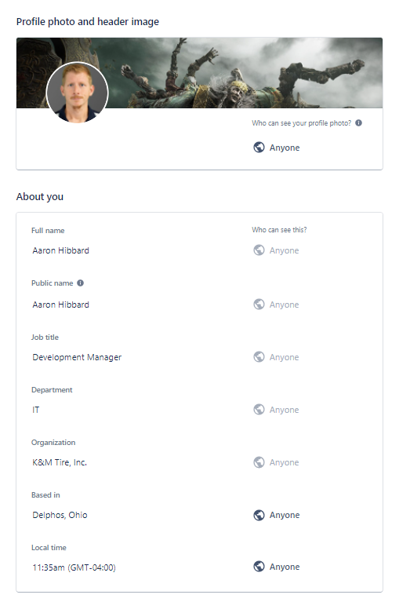

- Time Settings
  - Based on user since software could be used in several time zones.
  - America/New York
  - MM/DD/YYYY
  - 12-Hour
  - Monday
  - 8:00 AM

Time Tracker
- What are you working on?
  - This is all setup through Jira.
- Starting and stopping timer
  - Go to planning -> Roadmap
    - Administrator sends invite to email through admin.atlassign.com
  - Select Epic and Task that you’ll be working on
  - Go to Clockwork Free in Task Details
  - Click Go Arrow to Start Time
  - Click Stop Arrow to Stop Time
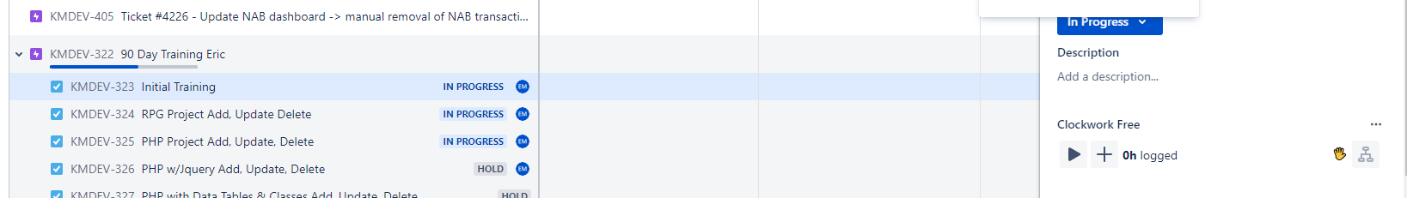
- Manually putting in time
  - Click + button on Clockwork (Free)
    - Put in Time Spent working on project
- Editing Time
  - You can go and fix the time on any already recorded records
    - Go to worklog underneath Clock Work Free
    - Find Timeframe, go to 3 dots and select Edit
    - You can modify your time and add any descriptions to that timeframe.

Dashboard
- Overview of Team
  - The Roadmap gives a picture of where all the projects are currently at.
  - You can sort by Developer Assigned, Labels, and Types of tasks.
  - You can run for just you or your Team.
  - This is a sample of a Developer’s schedule currently.
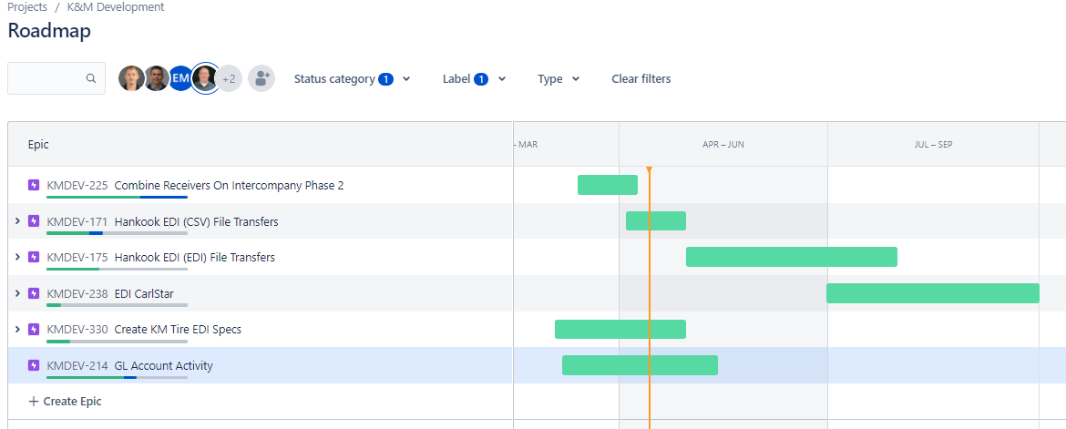
  - This is all setup through Ji

Reports
- Export the timesheet into Excel and modify it into monthly communication.
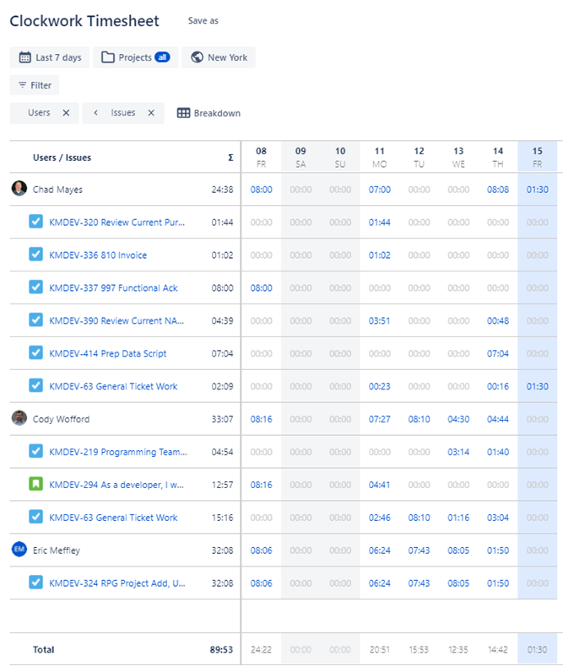

Projects
- Create New Epic
  - On Roadmap, click + Create Epic
  - Fill in what needs to be done (Name of “Project”)
    - Add in Description
    - Assign it to developer if Current Project or known
    - Drag and drop any documents with project
    - Label as type of project: CurrentProject, Upcoming, Etc.
    - Drag timeline for approximate start and end dates
- Create Tasks
  - Click on created Epic
  - Fill in what needs to be done (Name of “Task”)
  - Click add to add task underneath project
    - Same type of information for Epic but for the smaller subset task

Support
- Help
  - https://www.youtube.com/watch?v=nHuhojfjeUY

Departmental KPIs for Development

Total Tickets Solved

Average Time to Resolution

Total Time Open

Projects Closed for the Month

Estimated vs Actual Completion Time

Online Order Statistics

Frequently Asked Questions
K&M instructions: Provide information on how the Warehouse Manager can get emergency assistance and system support (e.g., help desk support, inventory support, etc.). Include the names of the responsible personnel and organization(s), telephone numbers, and email addresses of the staff who serve as points of contact for system support.

Table 1 - Support Points of Contact
Contact / | Department | Phone | Email | Role
K&M Corporate Line | Corporate | 419-695-1061 | n/a

Appendix A: Miscellaneous
Add links here

Appendix B: Supportive Department Summaries
How we can help at the field level?
Inventory Specialist:
Sales Department:
Purchasing Department:
Credit Department:

Instructions: Provide a list of acronyms and associated literal translations used within the document. List the acronyms in alphabetical order using a tabular format as depicted below.

Table 2 - Acronyms
Acronym | Literal Translation
<Acronym> | <Literal Translation>

Appendix C: Glossary
Instructions: Provide clear and concise definitions for terms used in this document that may be unfamiliar to readers of the document. Terms are to be listed in alphabetical order.
Table 3 - Glossary
Term | Acronym | Definition
Appendix D: Referenced Documents

Table 4 - Referenced Documents
Document Name | Document Location and/or URL | Issuance Date
Appendix E: Approvals
The undersigned acknowledge that they have reviewed the User Manual and agree with the information presented within this document. Changes to this User Manual will be coordinated with, and approved by, the undersigned, or their designated representatives.
Instructions: List the individuals whose signatures are desired. Examples of such individuals are Business Owner, Project Manager (if identified), and any appropriate stakeholders. Add additional lines for signature as necessary.
Table 5 - Approvals
Document Approved By | Date Approved
Name: <Name>, <Job Title> - <Company> | Date
Name: <Name>, <Job Title> - <Company> | Date
Name: <Name>, <Job Title> - <Company> | Date
Name: <Name>, <Job Title> - <Company> | Date
Appendix F: Additional Appendices
K&M Usage: Utilize additional appendices to include additional data, charts, etc.

Appendix G: Notes to the Author/Template Instructions
This document is a template for creating a User Manual for a given investment or project. The final document should be delivered in an electronically searchable format. The User Manual should stand on its own with all elements explained and acronyms spelled out for reader/reviewers, including reviewers outside CMS who may not be familiar with CMS projects and investments.
This template includes instructions, boilerplate text, and fields. The developer should note that:
- Each section provides instructions or describes the intent, assumptions, and context for content included in that section. Instructional text appears in blue italicized font throughout this template.
- Instructional text in each section should be replaced with information specific to the particular investment.
- Some text and tables are provided as boilerplate examples of wording and formats that may be used or modified as appropriate.
When using this template, follow these steps:
- Table captions and descriptions are to be placed left-aligned, above the table.
- Modify any boilerplate text, as appropriate, to your specific investment.
- Do not delete any headings. If the heading is not applicable to the investment, enter “Not Applicable” under the heading.
- All documents must be compliant with Section 508 requirements.
- Figure captions and descriptions are to be placed left-aligned, below the figure. All figures must have an associated tag providing appropriate alternative text for Section 508 compliance.
- Delete this “Notes to the Author/Template Instructions” page and all instructions to the author before finalizing the initial draft of the document.
Appendix H: Revision History Tracking
The following table records information regarding changes made to the Operations Binder.

Table 6 - Revision History Tracking
Version Number | Date | Author/Owner | Description of Change
2.0 | 1-Mar-22 | Josh Gillespie/Bryan Benner/IT Team | Baseline Version

